HTML ASSIGNMENT – 01

NAME: KOTA. VENKATESH BATCH: 111r
Topics: Introduction to HTML, History of HTML, Structure of HTML, Basic HTML Tags, Formatting Tags, Links
Part A – Theory Questions
1 What is HTML?
A. HTML is a markup language used to create and structure web pages.
2 Why was HTML introduced?
A. HTML was introduced to create and share documents on the World Wide Web.
3 What is the full form of HTML?
A. HTML – Hypertext Markup Language
4 Who introduced HTML?
A. Tim Berners-Lee introduced HTML.
5 Write a short note on the history of HTML.
A. HTML was created by Tim Berners-Lee around 1990 for the World Wide Web.
6 What is the purpose of <!DOCTYPE html>?
A. It tells the browser that the document is HTML5.
7 Explain the basic structure of an HTML document.
A. <!DOCTYPE html>, <html>, <head>, and <body> are the main parts.
8 What is the difference between <head> and <body>?
A. <head> contains page information; <body> contains visible content.
9 What is an HTML tag?
A. An HTML tag is a keyword inside < > used to define webpage elements.
10 What is the difference between opening and closing tags?
A. Opening tag starts an element, while closing tag ends it.
Example: <p> and </p>.

Part B – Basic HTML Tags
1 Write the use of: <html>, <head>, <title>, <body>, <h1>–<h6>, <p>, <br>, and <hr>.
A.<html> → Defines the HTML document.
<head> → Contains page information.
<title> → Sets the webpage title.
<body> → Contains visible webpage content.
<h1>–<h6> → Creates headings from largest to smallest.
<p> → Creates a paragraph.
<br> → Adds a line break.
<hr> → Creates a horizontal line.
2 Write an HTML program to display your name, college name, course, and city.
A. <!DOCTYPE html>
<html>
<head>
<title>my details</title>
</head>
<body>
<p>Name: venkatesh</p>
<p>College: Sri GCSR College</p>
<p>Course: B.Sc Computer Science</p>
<p>City: Rajam</p>
</body>
</html>

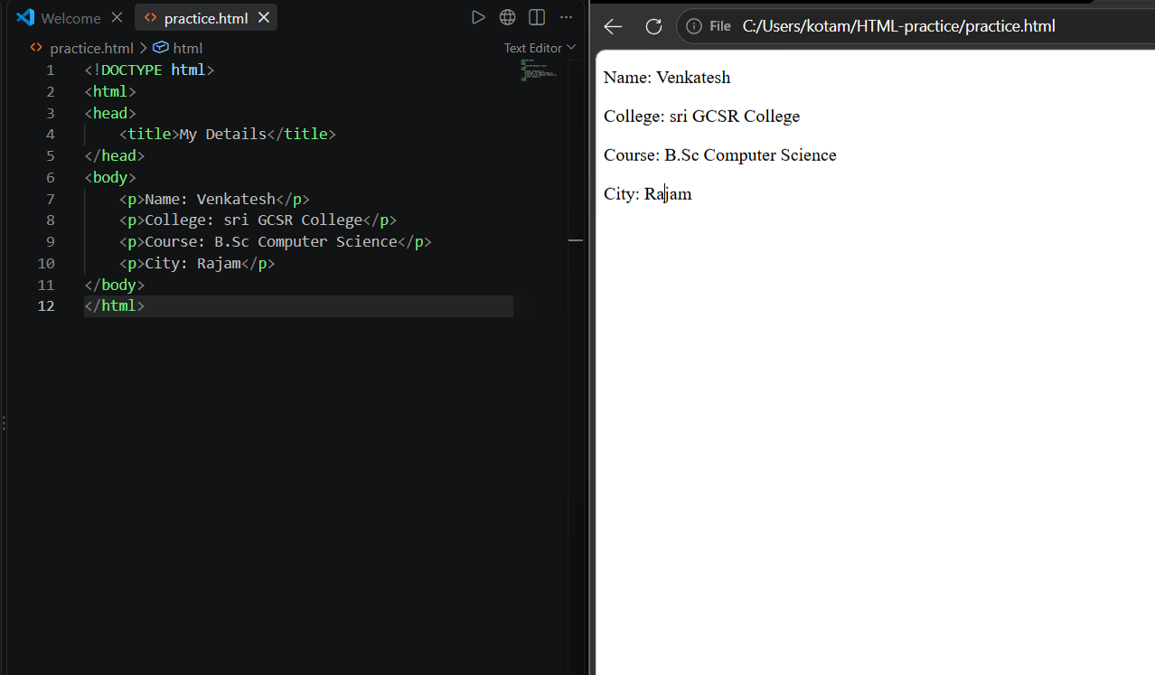
3 Create a webpage using all six heading tags (<h1> to <h6>).
A. <!DOCTYPE html>
<html>
<head>
<title>my details</title>
</head>
<body>

<h1>Name: venkatesh</h1>
<h2>College: Sri GCSR College</h2>
<h3>Course: B.Sc Computer Science</h3>
<h4>City: Rajam</h4>
<h5>State: Andhra Pradesh</h5>
<h6>Country: India</h6>
</body>
</html>

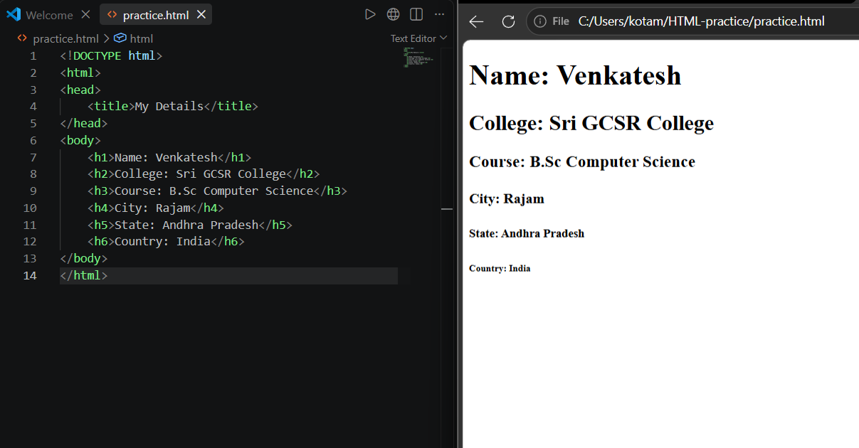
4 Create a webpage containing three paragraphs with a horizontal line between them.
A. <!DOCTYPE html>
<html>
<head>
<title>my details</title>
</head>
<body>

<h1>Name: venkatesh</h1>
<hr>
<h2>College: Sri GCSR College</h2>
<hr>
<h3>Course: B.Sc Computer Science</h3>
<hr>
<h4>City: Rajam</h4>
<h5>State: Andhra Pradesh</h5>
<h6>Country: India</h6>
</body>
</html>

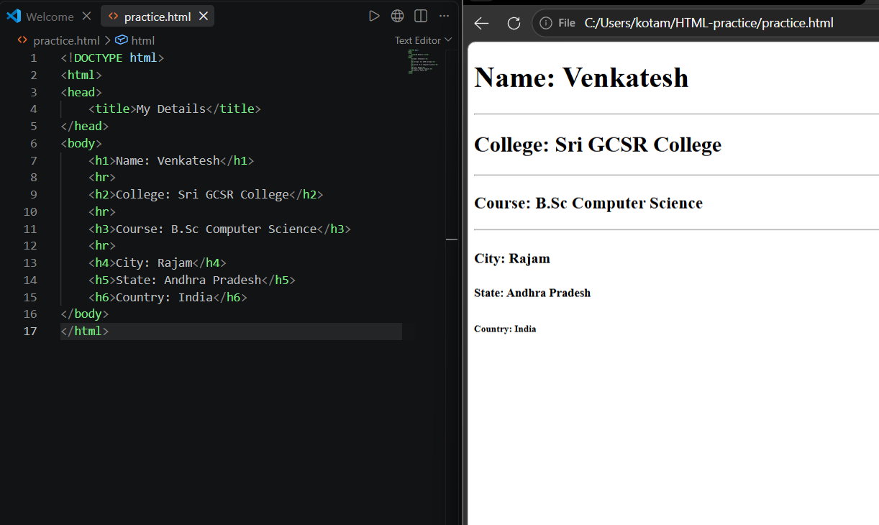
Part C – Formatting Tags
1 Write the purpose of: <b>, <strong>, <i>, <em>, <u>, <mark>, <small>, <del>, <sup>, and <sub>.
A. <b> → Bold text
<strong> → Important text
<i> → Italic text
<em> → Emphasized text
<u> → Underlined text
<mark> → Highlighted text
<small> → Small text
<del> → Deleted text
<sup> → Superscript
<sub> → Subscript
2 Create a webpage showing your name using bold, italic, and underline formatting.
A. <!DOCTYPE html>
<html>
<head>
</head>
<body>

<b>venkatesh</b>
<i>venkatesh</i>
<u>venkatesh</u>

</body>
</html>

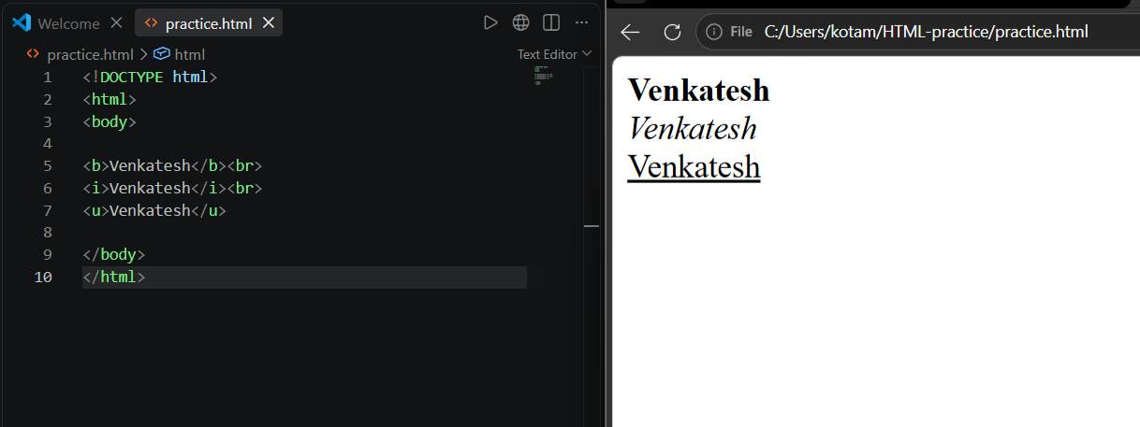
3 Write HTML to display H O, X² + Y², and 1000 as deleted price with 800 as current price.
A. <!DOCTYPE html>
<html>
<head>
</head>
<body>
H<sub>2</sub>O<br>
X<sup>2</sup> + Y<sup>2</sup><br>
<del>1000</del> 800
</body>
</html>

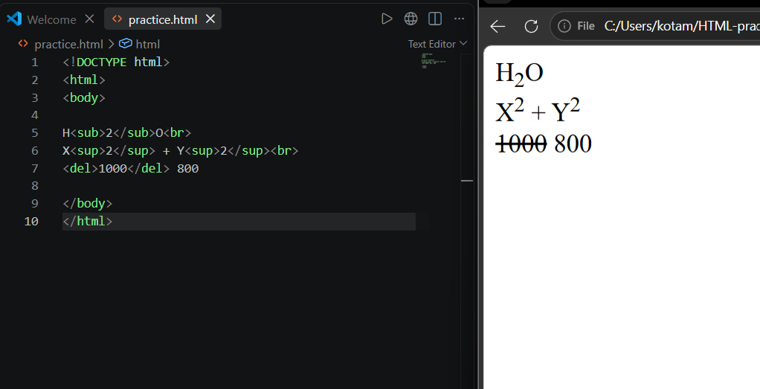
Part D – Links
1 What is a hyperlink?
A. A hyperlink is a clickable link that takes you to another webpage or resource.
2 Which HTML tag is used to create a link?
A. The <a> (anchor) tag is used to create hyperlinks.
3 What is the purpose of the href attribute?
A. <href> specifies the URL/address where the link should go
4 Create a link to Google.
A. <a href="https://www.google.com">Google</a>
5 Create a link to YouTube.
A. <a href="https://www.youtube.com">YouTube</a>
6 Create a link that opens in a new tab.
A. <a href="https://www.google.com" target="_blank">Google</a>
7 Create a webpage with links to Google, YouTube, and your college website.
A. <!DOCTYPE html>
<html>
<head>
<title>My LINKS</title>
</head>
<body>

<h2>Useful Links</h2>

<a href="https://www.google.com">Google</a><br>
<a href="https://www.youtube.com">YouTube</a><BR>
<a href="https://www.srigcsrcollege.org/">my College</a><BR>
</body>
</html>

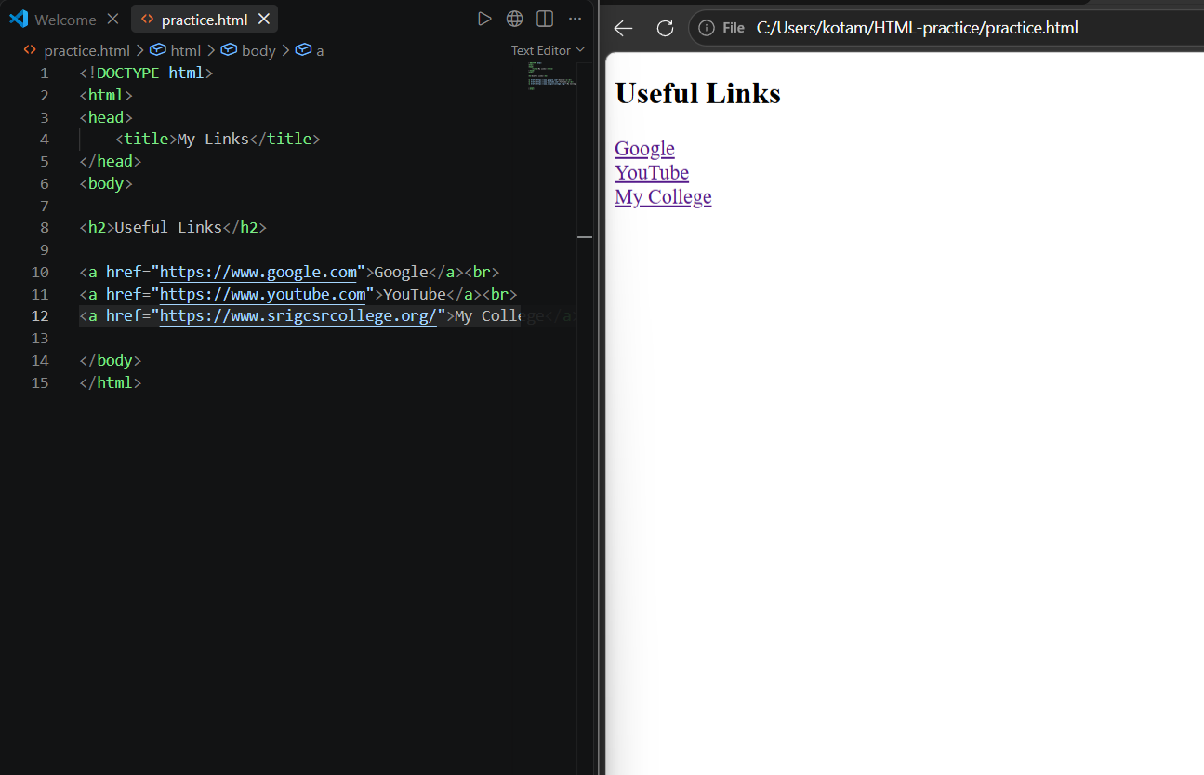

Practical Task – My Profile Webpage
Create a simple “My Profile” webpage containing your name as the main heading, a short introduction, college name, course, city, at least 3 formatting tags, a horizontal line, and links to Google and YouTube.
A. <!DOCTYPE html>
<html>
<head>
<title>My Profile</title>
</head>

<body>

<h1>Venkatesh</h1>

<p>Hello! My name is <b>Venkatesh</b>. I am a student interested in
<i>web development</i> and <u>programming</u>.</p>

<hr>

<h3>My Details</h3>

<p><strong>College:</strong> Sri GCSR College</p>
<p><strong>Course:</strong> B.Sc Computer Science</p>
<p><strong>City:</strong> Rajam</p>

<hr>

<h3>Useful Links</h3>

<a href="https://www.google.com" target="_blank">Google</a><br>
<a href="https://www.youtube.com" target="_blank">YouTube</a>

</body>
</html>

